Kinsmen Barbershop

User Flow Guide
Role based journeys for booking, product reservation and operational management
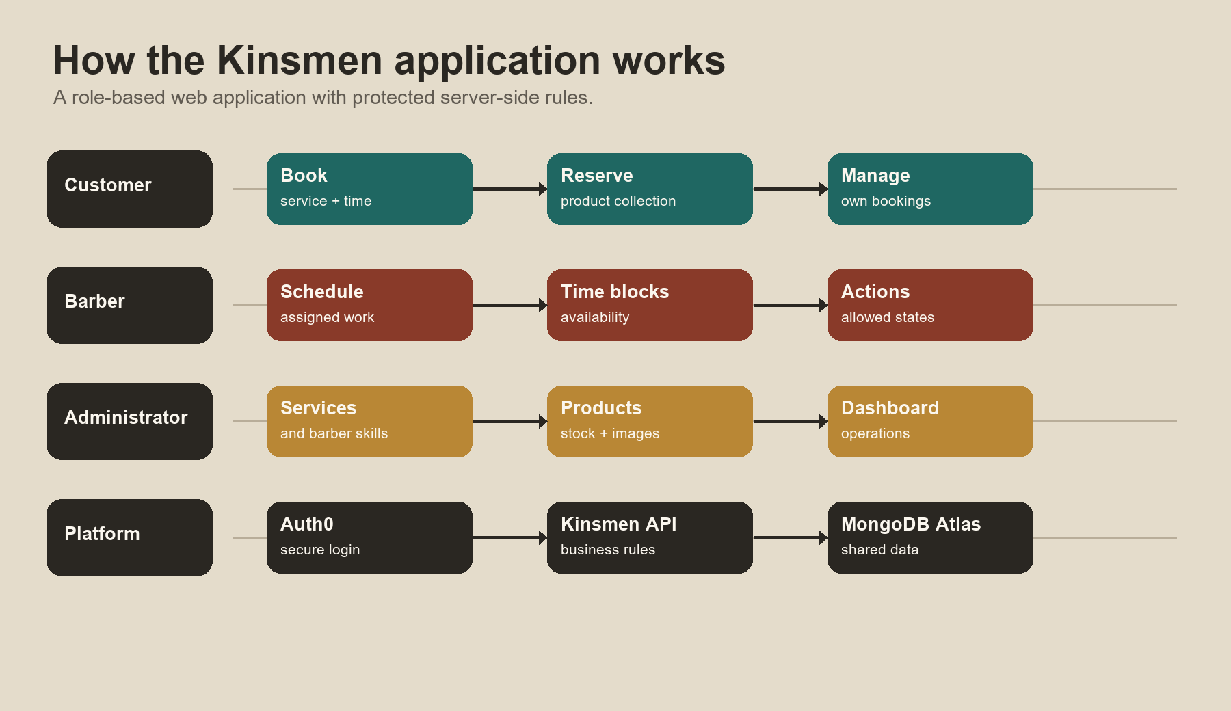
Figure 1. Kinsmen brings customer, barber and administrator work together through protected application services.
INSY7315 Work Integrated Learning
Emerald Solutions
4 November 2026

Purpose and scope
This guide explains how the Kinsmen Barbershop application moves information between people, screens and server-side rules. It is designed for the final demonstration, handover discussion and safe testing. The diagrams show responsibilities at a high level; they do not expose credentials, connection strings or private customer data.

Role summary
Role | Primary goal | Main controlled actions
Customer | Create and manage an own booking | Choose services, suitable barber/time, reserve products, reschedule/cancel, update profile.
Barber | Manage own assigned work | View schedule, add time blocks, and use permitted appointment actions.
Administrator | Maintain operational data | Manage services, barber skills, products, stock, and dashboard information.

System overview
The browser provides the interface, while the Kinsmen API enforces booking, authorisation and stock rules. Auth0 supplies sign-in and role information. MongoDB Atlas stores shared operational data. This separation prevents a browser-only value from deciding an important booking or stock outcome.
Figure 2. Overview of the application roles and core platform components.

Customer journey
The customer journey begins with authentication and ends when the customer sees the booking result in their own booking area. A product can be reserved for in-store collection during the journey. It is not an online-payment or delivery process.
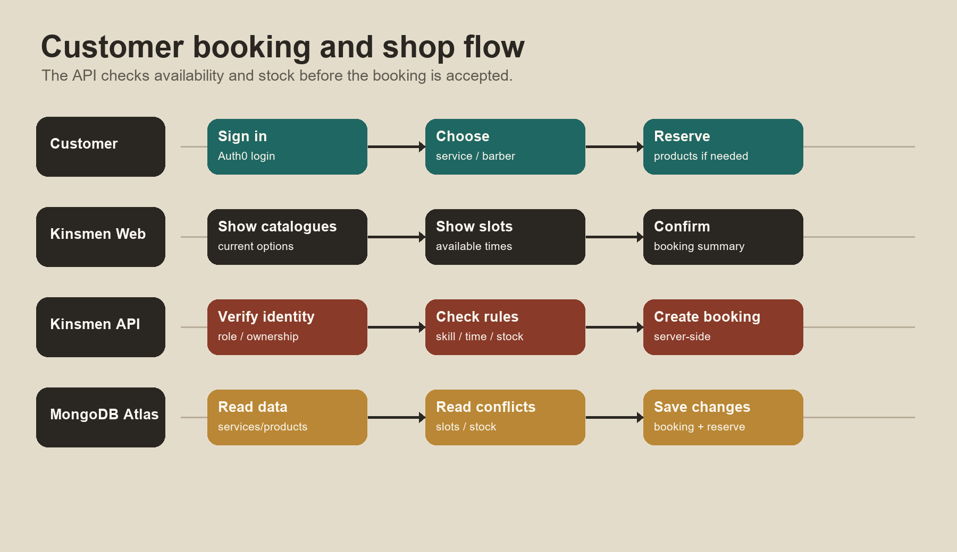
Figure 3. Customer booking and product-reservation journey.

Customer flow steps
- 1. Sign in: The customer uses Auth0 Universal Login before protected booking actions.
- 2. Choose services: The application presents active catalogue services.
- 3. Choose barber and time: The customer selects a suitable barber and an available time. The server considers availability, duration and blocked periods.
- 4. Add products if wanted: The customer can reserve available products for collection with the booking.
- 5. Confirm: The API verifies ownership, booking rules and stock before writing the result to shared data.
- 6. Manage booking: The customer uses My Bookings to view, reschedule or cancel an eligible future booking. Cancellation can restore product reservations.

Barber journey
A barber must have both the appropriate role and an operational link to the correct barber profile. This ensures the staff schedule represents the right person rather than merely any signed-in account.
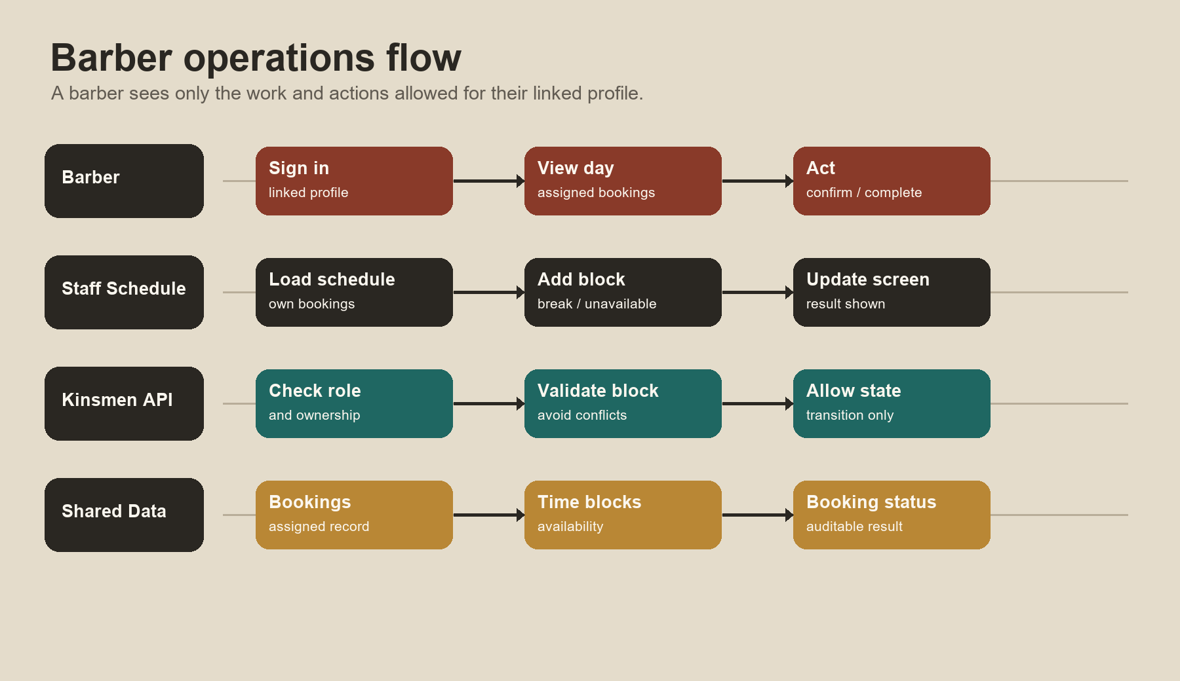
Figure 4. Barber schedule, availability and permitted appointment-action journey.

Barber flow steps
- 1. Sign in: The barber signs in through Auth0 using an account linked to the relevant barber profile.
- 2. View assigned work: The staff schedule loads appointments assigned to that barber.
- 3. Maintain availability: The barber can add a time block for a break or unavailable time, avoiding a conflict with existing work.
- 4. Take a permitted action: For a safe test appointment, the barber can use a state action presented by the application, such as confirming or completing an appointment.
- 5. Boundary check: The API rejects attempts to manage another barber’s appointments.

Administrator journey
Administrator screens exist to maintain the data that affects booking decisions and customer visibility. The group should use a safe test record during demonstrations and restore any modified stock or test value afterwards.
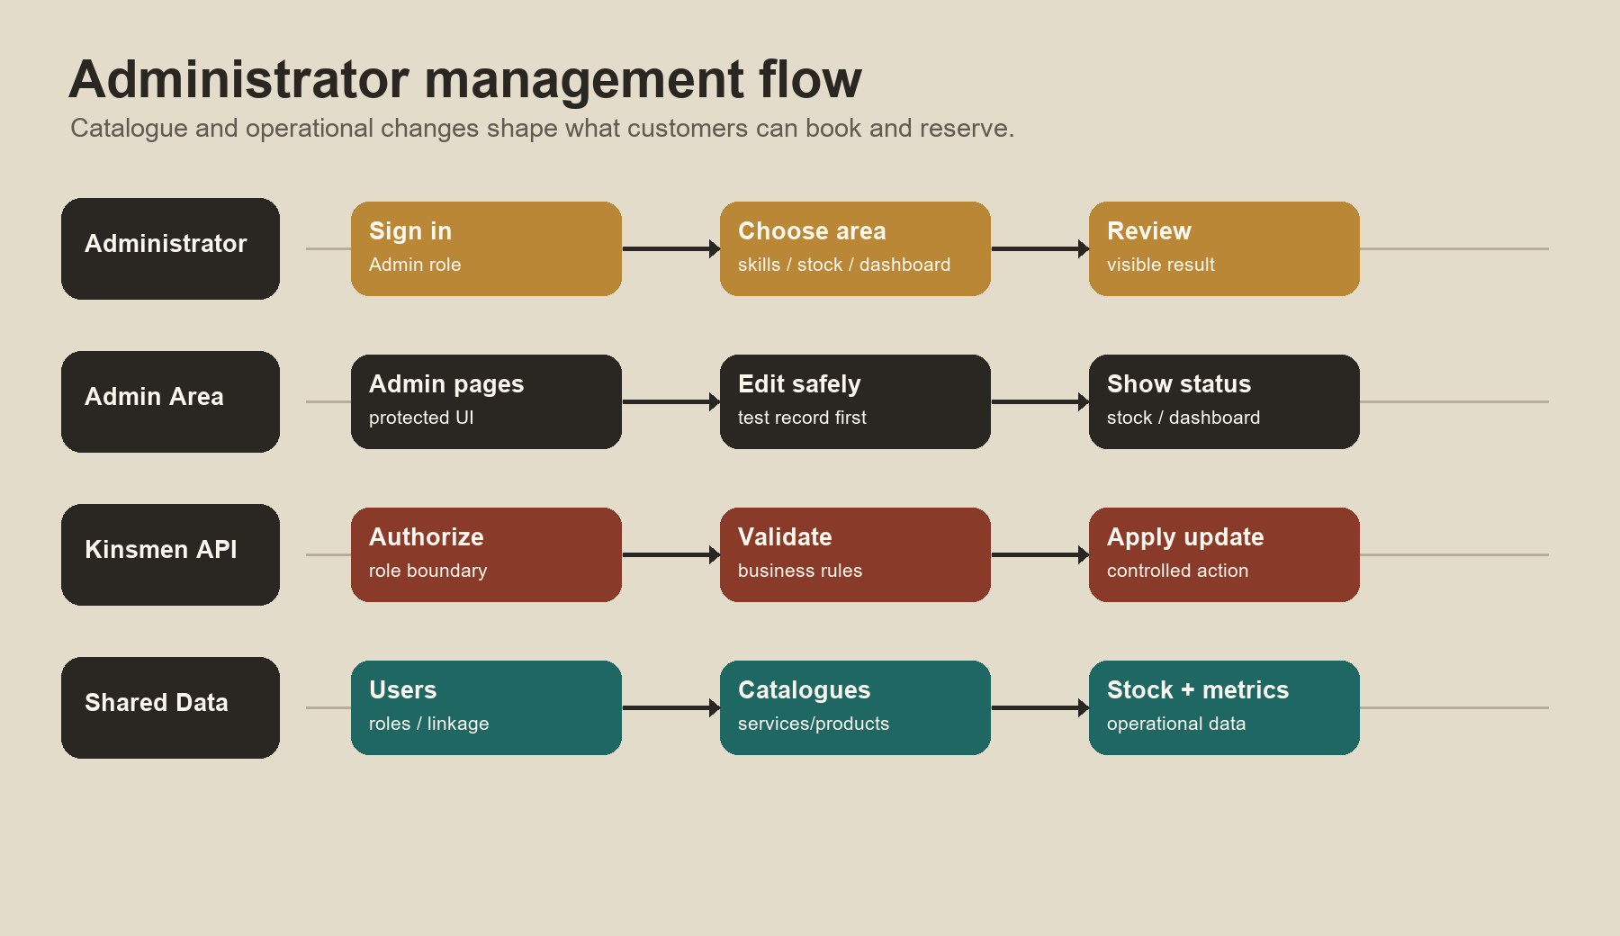
Figure 5. Administrator catalogue and operational-management journey.

Administrator flow steps
- 1. Access the admin area: An Admin role is required before protected controls are displayed or accepted.
- 2. Maintain services and skills: Service and barber-skill information is used to determine which barbers can be offered for selected services.
- 3. Maintain products and stock: Administrators can maintain product metadata, image location, visibility, stock and low-stock threshold. Stock adjustments should use the intended stock-control path.
- 4. Review operations: The dashboard can present totals, most-booked services and low-stock information.
- 5. Confirm the effect: After an update, confirm the visible customer or staff result without exposing sensitive data.

Key rules and exception paths
Situation | Expected system behaviour | Safe demonstration response
Chosen barber cannot perform service | Do not offer/accept the incompatible named-barber booking. | Select an eligible barber or an any-available choice.
Time slot is no longer available | Reject the conflicting booking rather than creating a double booking. | Choose a different available time.
Product stock is insufficient | Do not reserve more product than is available. | Use an in-stock test product or reduce quantity.
Booking with products is cancelled | Restore the reserved product quantity where the cancellation workflow applies. | Capture before/after stock only using safe test data.
User opens a restricted screen | Server-side role and ownership checks deny unauthorised changes. | Sign in with the correct role; do not bypass controls.

Demonstration sequence
A reliable demonstration is: customer sign-in, booking with a suitable barber/time, product reservation, booking confirmation, barber schedule view, administrator stock/skills view, then the dashboard. If the live Render service is waking, use the recorded or local Docker fallback only after explaining that it is a deployment availability delay, not a booking-rule result.

Document control
Prepared for the Kinsmen Barbershop final project submission. The supporting detailed user guide contains access instructions, troubleshooting and evidence-capture guidance. This flow guide should be updated if the final deployed branch materially changes a role, screen or rule.

